MLOps Cloud Engineering Lab – Practical

Title

Building and Training a Machine Learning Model for Telecom Tower Failure Prediction

Aim
To build, train, evaluate, and save a Machine Learning model using Python for predicting telecom tower hardware failures.

Software Required
- Python 3.11 or above
- Python IDLE (or VS Code)
- Internet Connection
- Command Prompt

Required Python Libraries
Open Command Prompt and install the following packages.
pip install pandas
pip install scikit-learn
pip install joblib

Expected Output
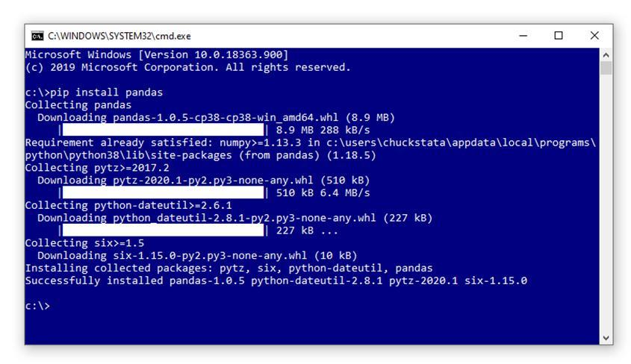
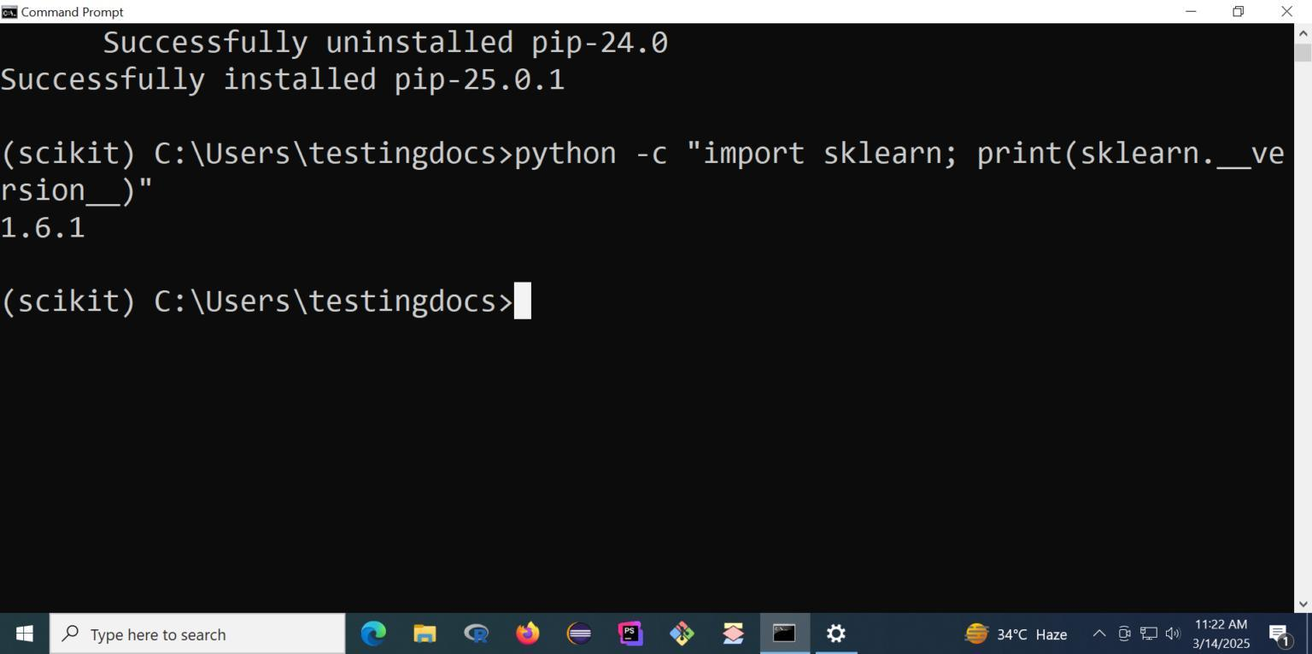
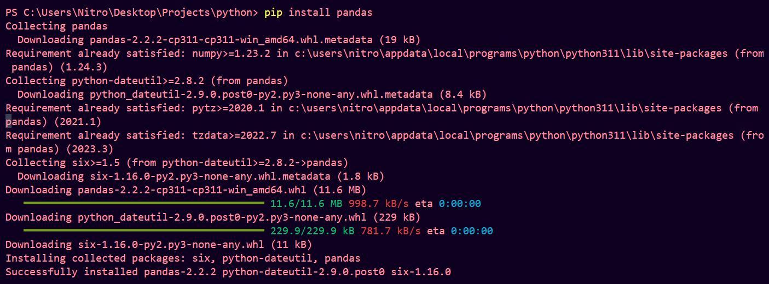
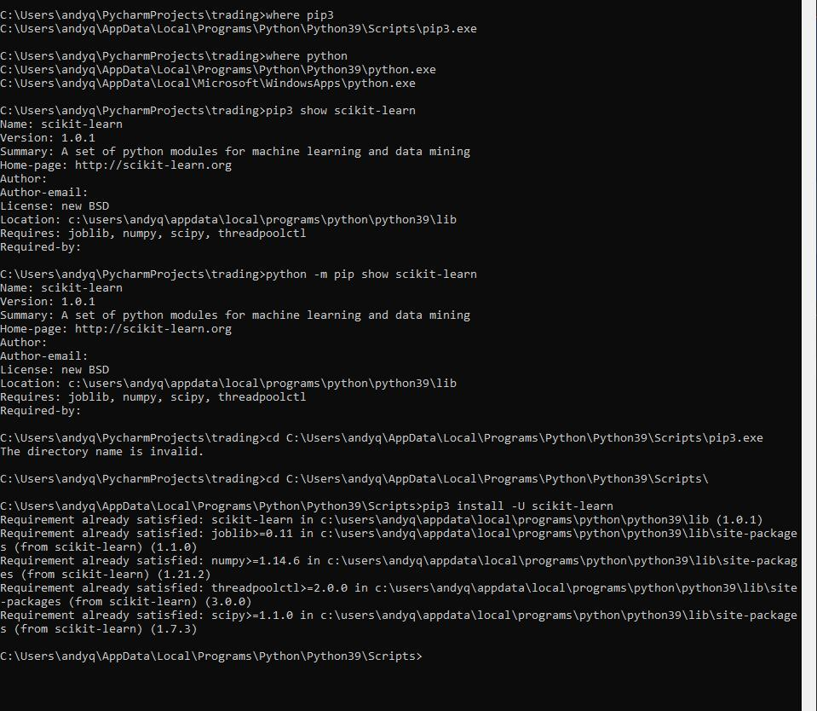

Students should see
Successfully installed...

Step 1

Create Project Folder
Create the following folder.
Desktop > MLOPS > mlops prac > prac_1

Inside prac1 paste
tower_telemetry.csv

Step 2

Create Python File
Open Python IDLE
New File
Save as train.py Inside prac_1

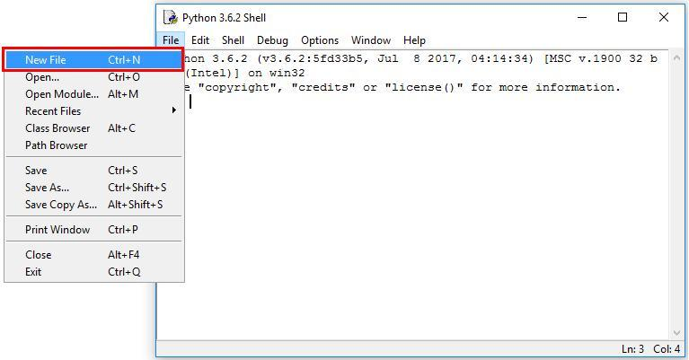
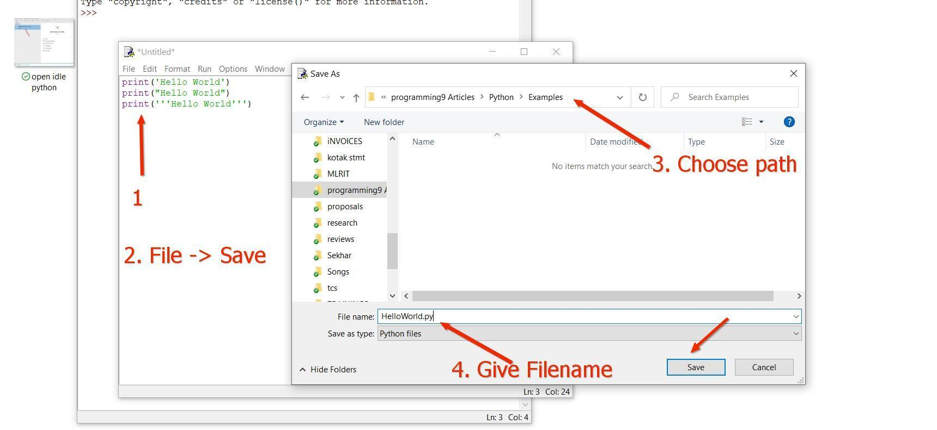
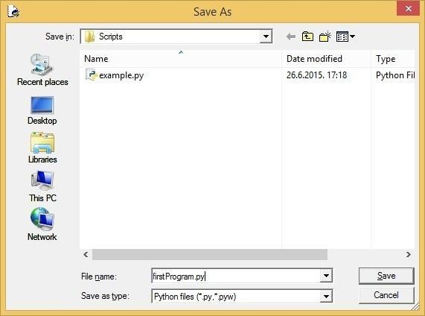
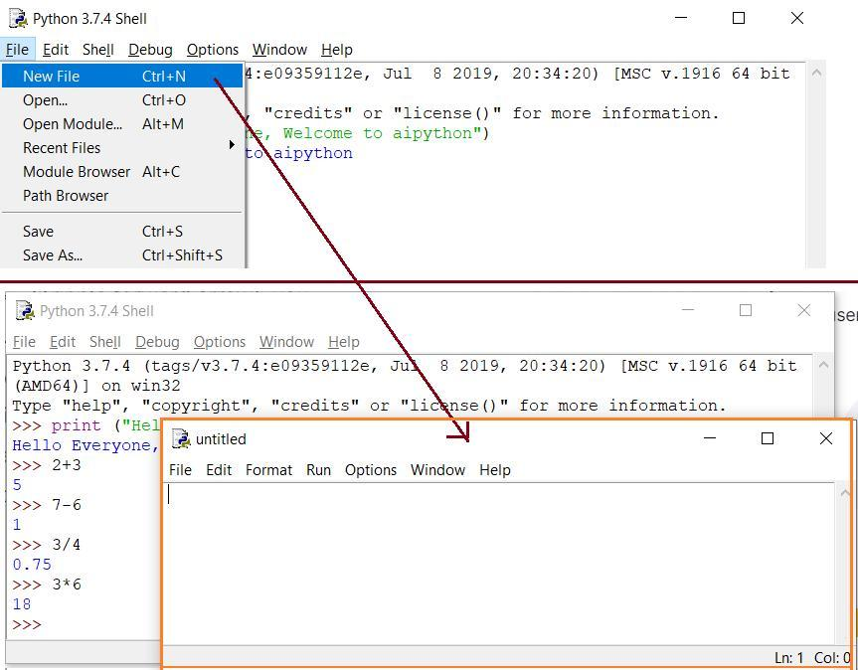
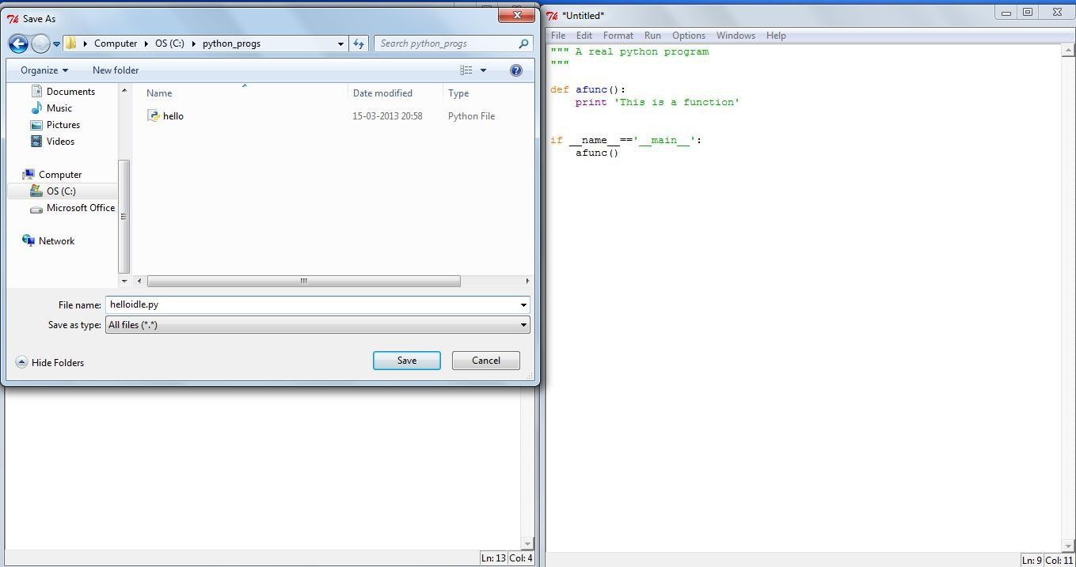

Step 3

Write Python Program
Paste the following program.
import pandas as pd
from sklearn.model_selection import train_test_split
from sklearn.ensemble import RandomForestClassifier
import joblib
import json

print("Loading Dataset...")
df = pd.read_csv("tower_telemetry.csv")
X = df[['voltage',
'temperature_c',
'signal_drop_rate',
'cpu_usage',
'battery_health',
'network_latency_ms']]
y = df['hardware_failure']
X_train,X_test,y_train,y_test = train_test_split(
X,
y,
test_size=0.25,
random_state=42
)
print("Training Model...")
model=RandomForestClassifier(
n_estimators=100,
random_state=42
)
model.fit(X_train,y_train)
accuracy=model.score(X_test,y_test)
print("Accuracy :",accuracy)
joblib.dump(model,"telecom_tower_model.pkl")
metrics={"accuracy":accuracy}
with open("metrics.json","w") as f:
json.dump(metrics,f,indent=4)
print("Training Completed Successfully")

Save the file.
Step 5

Run the Program
Open Command Prompt.
Go to your folder.
cd "C:\Users\sarve\Desktop\MLOPS\mlops prac\prac_1"
Run
python train.py

Expected Output
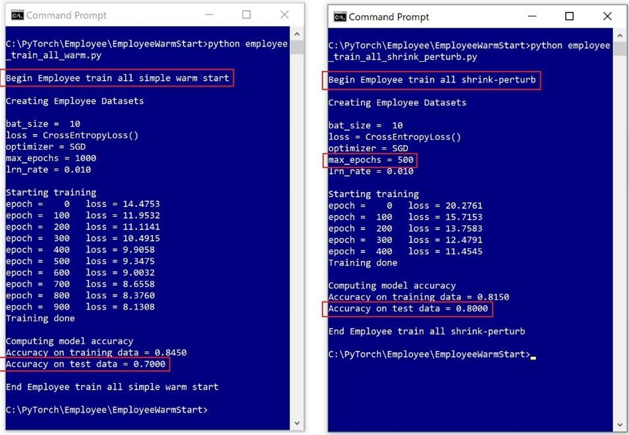

Students should see something similar to
Loading Dataset...
Training Model...
Accuracy : 1.0
Training Completed Successfully

Step 6

Check Generated Files

What are these files?
File | Purpose
tower_telemetry.csv | Training Dataset
train.py | ML Training Script
telecom_tower_model.pkl | Trained Machine Learning Model
metrics.json | Model Accuracy Report

Step 7

Create Prediction Program
Create another file
predict.py

import joblib
import pandas as pd
model=joblib.load("telecom_tower_model.pkl")
new_data=pd.DataFrame({
"voltage":[11.2],
"temperature_c":[55],
"signal_drop_rate":[0.5],
"cpu_usage":[88],
"battery_health":[65],
"network_latency_ms":[95]
})

prediction=model.predict(new_data)

if prediction[0]==1:

print("Hardware Failure Predicted")

else:

print("Tower is Healthy")

Save.

Step 8
Run Prediction
python predict.py

Expected Output
Hardware Failure Predicted
or
Tower is Healthy
depending on the prediction.

MLOps Cloud Engineering Lab – Practical 3

Step 9: Create an Amazon S3 Bucket

